Major Global Migration Flows
Name:

Data visualization is a trending movement that displays data and information in an eye-catching way. People who create data visualizations use a combination of graphic design and data analysis to create aesthetically pleasing ways to view and use data. The following data visualization is a global-migration, circular-flow chart that creatively displays immigration and emigration movement, across and between regions, over five year periods.

Instructions: Using the provided global-migration website, complete the following chart and the corresponding questions.
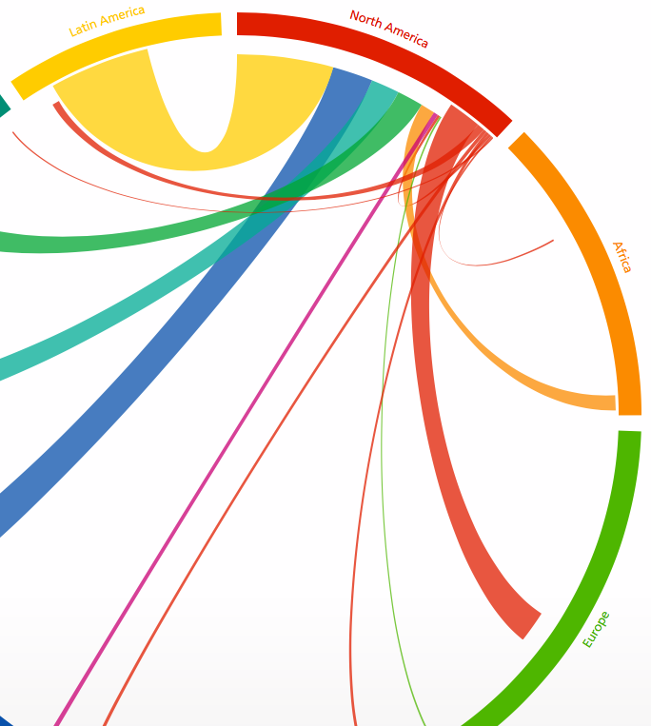
URL: http://www.global-migration.info

How to use the circular flow chart:
- Each segment of the colored ring represents a region of the world.
- If you tap on the region, it expands the view to individual countries.
- The colored lines flowing towards the “white” bar display the number of immigrants to the region, whose line size represents its value.
- The lines that share the same color as the region bar, display where emigrants of the given region are moving to.
- Hover/Tap on any of the lines to see the number of migrants between regions over the selected 5-year period.

Region | Largest In-Migration Trend from Another Region | Largest Out-Migration Trend from Another Region | Rank the regions with the Largest Interregional Migration. Hint: You may want to write the amount of migrants first, then rank).
North America | Ex: Latin America | Ex: Latin America | 96,102 (over 5 years)
Africa
Europe
Fmr Soviet Union
West Asia
South Asia
East Asia
South-East Asia
Oceania
Latin America

Think of three other situations where a circular plot chart would be an acceptable way to illustrate data.

List the regions that have a larger OUT-migration than IN-migration.

List the regions that have a larger IN-migration than OUT-migration.

Identify one regional migration flow between two regions that has a far proximity of distance.

Explain the social, economic, or political reason why these two regions have a large migration flow between the two.

Next, identify three regional migration flows from the above chart that have a direct correlation with the regions’ close proximity of distance to each other.

