Name: Date:
AP Human Geography

PROJECT: THIRD WORLD FARMER VS FIRST WORLD FARMER

INTRODUCTION
As a part of our examination of agriculture and its link to Human Geography, you will play two computer simulations, Third World Farmer and the National Museum of American History’s Farming Challenge. Afterwards you will compare and contrast the situations as presented within the two simulations.

THIRD WORLD (DEVELOPING NATION) FARMER SIMULATION

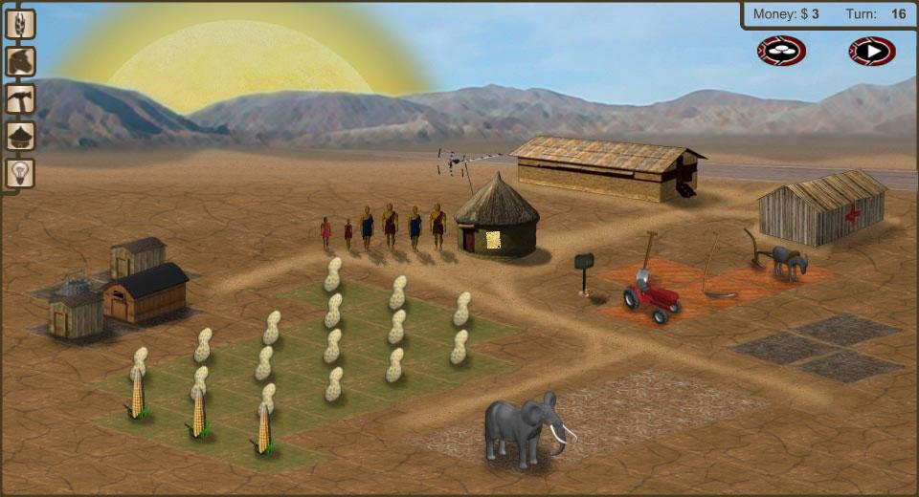
INTRODUCTION

Third World Farmer is a game that puts you in the shoes of a family of farmers in one of the poorest areas of the world. This simulation lets you make the important decisions that will determine if your family will prosper, or starve. Will you plant corn this year, or peanuts? Will you invest your few dollars in a new tractor, or pay off a local representative? Can you afford to send your children to school, or give them medicine? Third World Farmer lets you make the hard decisions!

INSTRUCTIONS
- Go to Third World Farmer at the following URL: http://www.3rdworldfarmer.com/
- Use the cursor to click on items to plant or buy. Use the cursor to click on family members for more options.
- Tips & Tricks (Being a poor farming family isn't easy, but hopefully these tips will help you scrape by.)
  - Keep the Family Healthy: Over time, each of your family members will get sick due to overwork and the environment. Try to save up money to treat the whole family at once, it's much more economical this way. Click on any family member, then click Give Medicine to see your options.
  - Invest in Infrastructure: While buying a cellular telephone or investing in a nearby road may seem like an extravagance, over the long term these items will pay off; not to mention boosting your final score.
FIRST WORLD (DEVELOPED NATION) FARMER SIMULATION

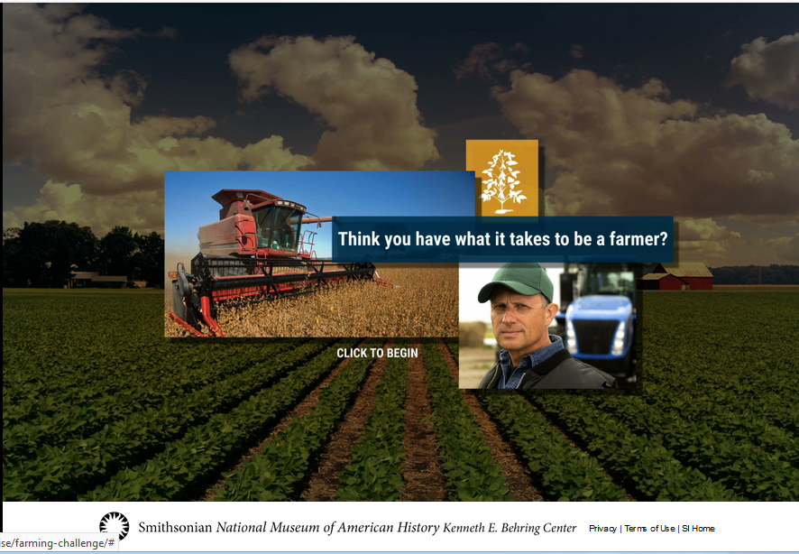

After looking at Food Inc. within class, you should have a better idea of the plight of farmers in the developed world. This simulation will allow you to make decisions about running a farm within the United States of America.
INSTRUCTIONS
- Go to National Museum of American History’s Farming Challenge at the following URL: https://amhistory.si.edu/american-enterprise/farming-challenge/
- Play through the simulation by following the provided prompts.

COMPARE AND CONTRAST

INSTRUCTIONS
While your answers to each of the posed questions may not be completely done in bullet points, bullet points may be used as part of each answer. REMEMBER: Bullet points are NEVER allowed on the FRQs on the AP Examination on Human Geography.

Also, REMEMBER that while the first simulation itself is called Third World Farmer, it is NEVER acceptable to use the terms Third World and First World in Human Geography. These phrases became outdated in 1991 when the Sickle and Hammer ceased to fly over the Kremlin and the Second World ceased to exist. ALWAYS use Developing and Developed, especially on the FRQs on the AP Examination.

1. Based upon the simulation (and material examined within Human Geography before the playing of these two simulations), what were the similarities between issues faced by farmers in the developing world (3rd World Farmer) and farmers within the developed world (Farming Challenge)?

2. Based upon the simulation (and material examined within Human Geography before the playing of these two simulations), what were the differences between issues faced by farmers in the developing world (3rd World Farmer) and farmers within the developed world (Farming Challenge)?

.

